15th CII Food Safety, Quality & Regulatory Digital Summit

*Food Safety & Quality 2030 with Innovations, Nutrition and Sustainability*

PROGRAM DETAILS

**15th CII Food Safety, Quality & Regulatory Digital Summit - 16th December 2020**:

**CII Member/Non-Member - Rs. 2,000 + 18% GST = Rs. 2,360**

**Student - Rs. 500 + 18% GST = Rs. 590/-**

Complimentary for CII Award for Food Safety 2020 Assessors (who took part in the Assessment

2020 )

* For confirmation of nominations, please forward your nominations along with the Bank Transfer details/Cheque/DD towards fee drawn in favour of **“Confederation of Indian Industry”** to the undersigned. RTGS/NEFT details are given below. For bank transfer, please share Payment Advice once done.
* Fee is neither refundable nor adjustable against any future programme. Changes in nominations are acceptable.
* **Cancellation Policy: 2 day Prior to the event: 100% of total fee to be paid by Nominating company**

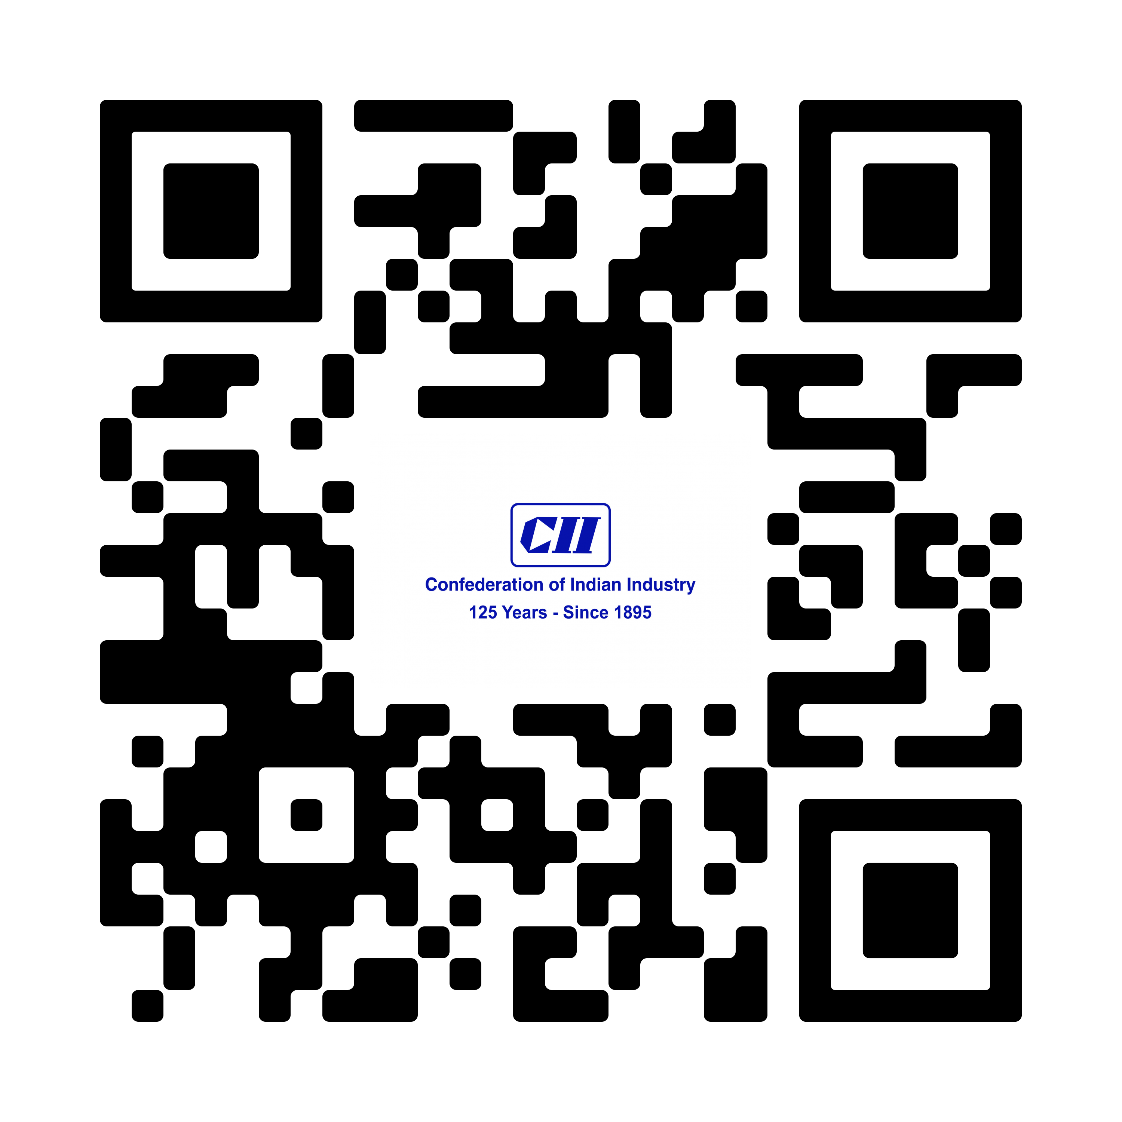

**Bank Details for Remittance**



### Beneficiary Name: Confederation of Indian Industry

**Bank Name:** Standard Chartered Bank, 23

Barakhamba Raod, Narain Manzil, New Delhi- 110001.

A/c number- 52205035775 & IFSC- SCBL0036020

CII GST Number- 07AAATC0188R1ZB

REGISTRATION DETAILS

**15th CII Food Safety, Quality & Regulatory Digital Summit**

***Food Safety & Quality 2030 with Innovations, Nutrition and Sustainability***

|  |  |  |  |
| --- | --- | --- | --- |
| **Sl. No** | **Name** | **Designation** | **Organization** |
| 1 |  |  |  |
| 2 |  |  |  |
| 3 |  |  |  |
| 4 |  |  |  |
| 5 |  |  |  |
| 6 |  |  |  |
| 7 |  |  |  |

**Nominations sent by:**

Name: ________________________________ Designation: __________________________________

GST No./PAN No _____________________________­_

Company Name as per GST (if applicable): ____________________________________________________________________

Address with PIN Code as per GST/ PAN (whichever applicable) : ____________________________________________________________________

Tel / Mobile: _________________________________________________________

Email: ____________________________________________________________

Ms. Anju Bist / Mr. Dhruv Sehgal

CII-Jubilant Bhartia Food & Agriculture Centre of Excellence

Mob: 9818878840 / 9711806473

Email: [anju.bist@cii.in](mailto:anju.bist@cii.in) / dhruv.sehgal@cii.in